**Capstone Project  
North Wind  
Traders  
Sales Analytics**

By: - Divyansh Mishra

**ABSTRACT**

The Power BI report for Northwind Traders offers a comprehensive overview of the company's operations, leveraging data from multiple tables to provide valuable insights into sales performance, customer behaviour, inventory trends, and employee effectiveness. By integrating information from the Customers, Employees, Orders, Order Details, Products, Suppliers, Shippers, and Categories tables, the report delivers a visually appealing and user-friendly dashboard. Key performance metrics such as sales analysis, customer segmentation, and employee performance are presented through interactive visualizations and dynamic filters, enabling stakeholders to make informed, data-driven decisions. The report aims to revolutionize how Northwind Traders interacts with its data, empowering the company to remain competitive and drive business growth in the wholesale market landscape.

**INDEX**

Project Overview……………………………………………………………………………………04

Key Components of the Report………………………………………………………………05

Information about Dataset Table………………………….…………………………..06-07

Data Cleaning……………………………………………………………………………………08-10

Primary Key and Foreign Key………………………………………………………………….11

ER Diagram……………………………………………………………………………………………12

MECE breakdown………………………………………………………………………………….13

Understanding and solving PowerBi ques…………………………………………14-30

Dashboard……………………………………………………………………………………….31-34

Solving EDA questions……………………………………………………………………..35-49

Conclusion………………………………………………………………………………………50-51

**PROJECT OVERVIEW**

**Objective:**  
The objective of this Power BI report is to develop a comprehensive dashboard for Northwind Traders, a fictitious company specializing in importing and exporting specialty foods. The report aims to provide valuable insights into various aspects of the company's operations, including sales analysis, customer segmentation, inventory trends, and employee performance. The primary goal is to facilitate data-driven decision-making processes for stakeholders by presenting key performance metrics in an intuitive and visually appealing manner.

**Dataset Description:**  
The dataset used for this project is the Northwind database, containing sales data for Northwind Traders. It comprises several interconnected tables, including Customers, Employees, Orders, Order Details, Products, Suppliers, Shippers, and Categories. Each table contains specific information related to customers, employees, orders, products, suppliers, and shipping details, enabling comprehensive analysis of the company's operations.

**Key Components of the Report:**

1. **Sales Analysis:**
   1. Visualizations depict sales trends over time, including total sales, sales by product category, and geographical distribution of sales.
   2. Analysis of top-selling products, customer segments, and sales performance by region or customer demographics.
2. **Customer Segmentation:**
   1. Segmentation of customers based on various attributes such as geographic location, purchase history, and customer type.
   2. Customer retention analysis and identification of high-value customers for targeted marketing strategies.
3. **Inventory Trends:**
   1. Visualizations illustrating inventory levels, including stock availability, products on order, and reorder levels.
   2. Analysis of inventory turnover rates, identifying slow-moving or obsolete products.
4. **Employee Performance:**
   1. Evaluation of employee performance metrics such as sales contribution, order processing time, and customer satisfaction ratings.
   2. Comparison of performance across different sales territories or teams.

**Information** **about** **Dataset** **Tables**

* What is Dataset?

A dataset is a collection of data.

* In this Project, we have got dataset from a company called “Northwind Traders”. A company that deals with importing and exporting food items across different countries.
* In this dataset, we have 8 different tables.
  1. Customers Table
  2. Employees Table
  3. Orders Table
  4. Order Details Table
  5. Products Table
  6. Suppliers Table
  7. Shippers Table
  8. Categories Table

**Tables and their columns: -**

**1. Customers Table:** - This table stores information about the company's customers. It includes fields for customer ID, company name, contact name, contact title, address, city, region, postal code, country, phone, and fax.

**2. Employees Table:** - This table stores information about the company's employees. It includes fields for employee ID, last name, first name, title, title of courtesy, birth date, hire date, address, city, region, postal code, country, home phone, extension, photo, notes, reports to, and photo path.

**3. Orders Table: -** This table stores information about the company's orders. It includes fields for order ID, customer ID, employee ID, order date, required date, shipped date, ship via, freight, ship name, ship address, ship city, ship region, ship postal code, and ship country.

1. **Order Details Table:** - This table stores detailed information about the items within each order. It includes fields for order ID, product ID, unit price, quantity, and discount.
2. **Products Table: -** This table stores information about the company's products. It includes fields for product ID, product name, supplier ID, category ID, quantity per unit, unit price, units in stock, units on order, reorder level, and whether the product is discontinued.
3. **Suppliers Table:** - This table stores information about the company's suppliers. It includes fields for supplier ID, company name, contact name, contact title, address, city, region, postal code, country, phone, fax, and home page.
4. **Shippers Table:** - This table stores information about the company's employees. It includes fields for employee ID, last name, first name, title, title of courtesy, birth date, hire date, address, city, region, postal code, country, home phone, extension, photo, notes, reports to, and photo path.
5. **Categories Table: -** This table stores information about the company's orders. It includes fields for order ID, customer ID, employee ID, order date, required date, shipped date, ship via, freight, ship name, ship address, ship city, ship region, ship postal code, and ship country.

**Data Cleaning**

After getting dataset we must understand each column in each table and perform data cleaning process on our data for further use.

* What is Data Cleaning?

The process of identifying, correcting, and removing errors, inconsistencies, and inaccuracies from a dataset to improve its quality and reliability for analysis. It is a crucial step in the data analysis workflow as it ensures that the data used for analysis is accurate, consistent, and complete. Data cleaning involves various tasks, including:

1. **Handling missing values:** Identifying and dealing with missing data points, which may involve imputation (replacing missing values with estimated values), deletion of incomplete records, or other strategies depending on the nature of the data and the analysis.
2. **Removing duplicates:** Identifying and removing duplicate entries in the dataset to avoid redundancy and ensure that each record is unique.
3. **Standardizing formats:** Ensuring consistency in data formats, such as date formats, units of measurement, and categorical variables, to facilitate analysis and comparison across different data points.
4. **Correcting errors:** Identifying and correcting errors in data entry, such as typos, outliers, or inconsistencies in data values, to improve the accuracy of the dataset.
5. **Handling outliers:** Identifying and addressing outliers, which are data points that significantly deviate from the rest of the dataset, by either correcting them if they are genuine data points or removing them if they are errors or anomalies.
6. **Dealing with inconsistencies:** Resolving inconsistencies in data values, such as conflicting information or discrepancies between different sources, to ensure data integrity and reliability.
7. **Validating data:** Verifying the accuracy and integrity of the data by cross-referencing it with external sources or validating it against predefined criteria or business rules.

Overall, data cleaning aims to prepare the dataset for analysis by ensuring that it is accurate, consistent, and reliable, thereby enabling meaningful insights to be derived from the data analysis process.

Data cleaning, I have done in this dataset.

1. Replacing null value with N/A from each tables having region column.

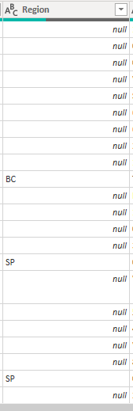

Before After

1. Delete unnecessary columns having null values in each row from each table such as report to, image, imagethumbnail, etc.

1. Formatting data columns in correct format such as DATE, DECIMAL, WHOLE NUMBER, TEXT, etc.
2. Created new columns based on questions requirements.

**After cleaning all the table, dataset is ready for the visualization.**

To visualise the dataset, first we must identify Keys in each table such as Primary Keys, Foreign Keys.

* **What is Primary Key and Foreign Key?**

A **primary key** is a column or set of columns in a table that uniquely identifies each row (or record) in that table. It must have a unique value for each row, and it cannot contain null values.

A **foreign key** is a column or set of columns in one table that refers to the primary key in another table. It establishes a link or relationship between two tables by referencing the primary key of one table as a foreign key in another table.

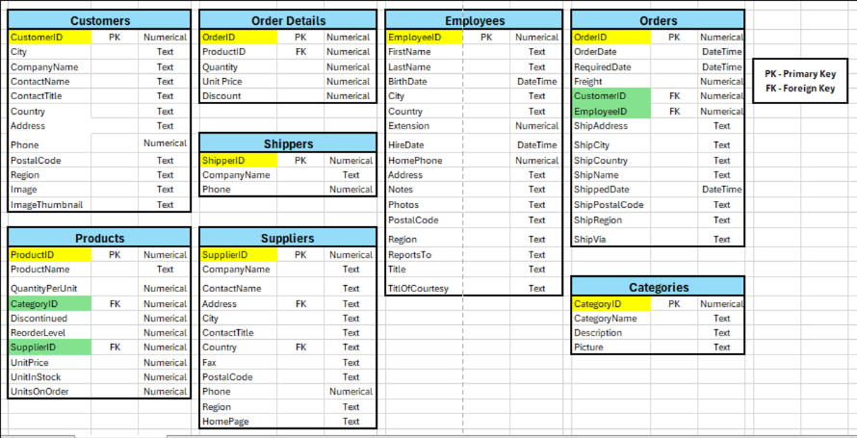**Identify all the keys in each table shown below:**

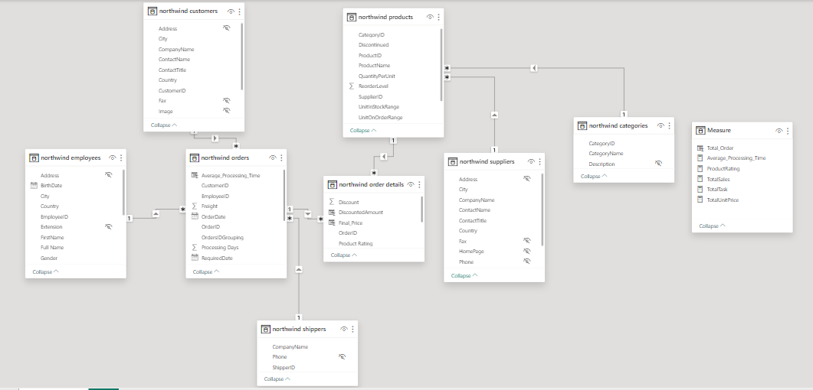**After all this task we have to create ER diagram for our dataset.**

**ER Diagram:**

Above ER diagram shows all the tables and their connections with each other. It will help use to understand the flow of connections and type of connection such as One-to-one or One-to-many. In this ER Diagram we have use One-to-one connection.

Tables connections:

1. Employees Table connected with Orders Table using EmployeeID.
2. Customers Table connected with Orders Table using CustomerID.
3. Orders Details Table connected with Orders Table using OrderID.
4. Shipper Table connected with Orders Table using ShipperID.
5. Products Table connected with Order Details Table using ProductID.
6. Products Table connected with Suppliers Table using SupplierID.
7. Products Table connected with Categories Table using CategoryID.

**After all this steps we can start with our questions.**

**MECE Breakdown**

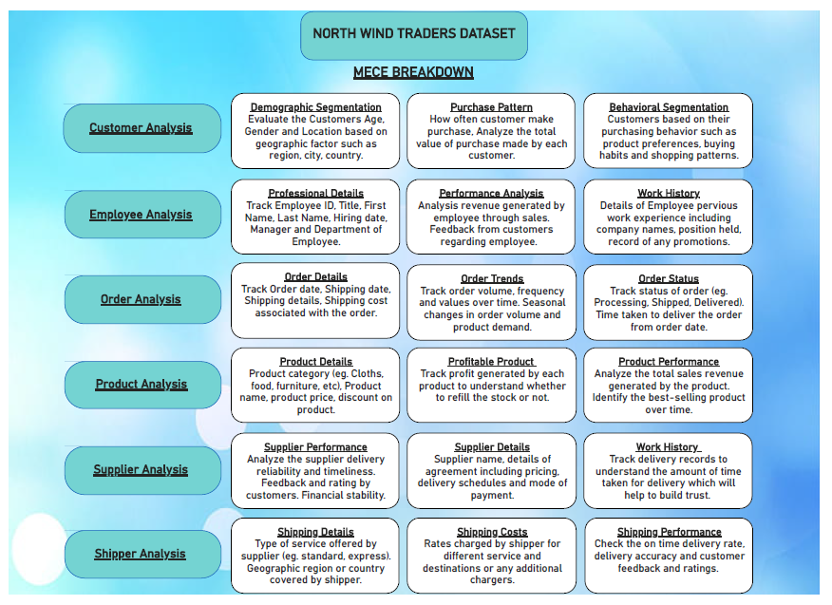MECE stands for "Mutually Exclusive, Collectively Exhaustive”. MECE breakdown refers to the principle of breaking down a problem or a set of information into mutually exclusive and collectively exhaustive (MECE) categories. This approach is commonly used in problem-solving, analysis, and communication to ensure clarity, completeness, and effectiveness. MECE breakdowns are essential because they provide a structured framework for organizing and understanding complex information, facilitating better decision-making and communication.

**Understanding & Solving Power** **Bi** **Questions**

In power bi we can divide questions into 5 different categories.

1. **Customers Analysis:** - It contains all the record of Customers such as Customer ID, Company name, contact name, contact title, City, Country, etc. which help us to find customer distribution, acquisition, and demographic information.
2. **Employee Analysis:** - It contains all the records of employees such as Emp ID, first name, last name, Date of birth, hire date, city, country, etc. it helps us to solve questions related to employee tenure, employee productivity and employee performance.
3. **Order Analysis: -** It contains all the records related to orders such as Order ID, order date, required date, shipped date, ship name, ship via, ship address, etc. it will answer the following questions such as average order processing time, order volume and order value.
4. **Product Analysis: -** It stores all the products record such as Product ID, Product name, quantity, unit price, unit in stock, unit on order, etc. it help us to show pricing of product, sales volume across different categories, product ratings.
5. **Supplier Analysis: -** It stores records such as Supplier ID, supplier company name, supplier contact name, contact title, city, country. It will help us to find geographical distribution of supplier, pricing structure of supplier and supplier performance.

* **To solve questions, we have to make few columns & measures based on the requirements.**

I have created few columns & measures for dataset based on my requirements.

**Measures**

**Columns**

* **Different between Measures and Columns**

**Measures:**

1. Measures are dynamic calculations based on the data in the model.
2. They are created using DAX (Data Analysis Expressions), a formula language in Power BI, and can perform calculations such as sums, averages, counts, or more complex aggregations.

**Columns:**

1. Columns are fields in a table that contain static data values for each row.
2. They are derived from the underlying data source or calculated during data loading using Power Query (M language).
3. Columns represent attributes or characteristics of the data, such as customer names, product categories, or order dates.

**Question 1:** **How does customer distribution vary across different regions or customer segments? Can we visualize it on a map or bar chart?**

**Answer:**

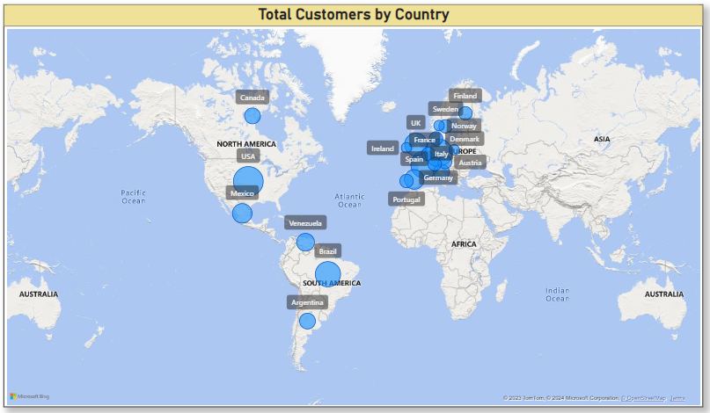

In this I have used map chart to show customers distribution across different countries, it will help us to identify which countries have maximum customer distributions.

Yes, we can create map chart to visualize this question. In this question

I have used “Country” in location section and “Count of CustomerID” in bubble size. It will count the customers using count function and display the total number of customers in each country.

**Question 2:** - What is the trend in customer acquisition over time? Can we create a line chart or area chart to display it?

**Answer**:

Yes, we can create line chart to analyze trend over time. To create this visualization, I have used “OrderDate” from order table in X-axis and “Count of CustomerID” from order table in Y-axis. It will count the total number of customers in months and years, which will help us to find maximum customers in which year. Its shows **maximum number of customers in April 1996 having 77 customers and oct 1994 having minimum 22 customers.**

**Question 3:** - Can we visualize the distribution of customer demographics such as age, gender, or income using histograms or pie charts?

**Answer:**

Yes, we can create pie chart to find customers demographic, to calculate distribution of customers I have use contact role from demographic. It will provide us the number of customers in each contact role which will help us to analyse which role is having maximum distribution. I have used “ContactTitle as Contact Role” from customer table in Legend and “Count of Customer ID” from customer table in Values. It shows **“Sales Representative” have highest number of customers having 18.68%**.

**Question 4: -** How does order volume change over time? Can we create a time series chart or stacked bar chart to visualize it?

**Answer**: Yes, we can create time series charts to visualise changes in order volume over time.

I have use “OrderDate” from Order table in X-axis and “Count of OrderID” from Order table in Y-axis. To find the trend of number of orders in different months, quarters & years. It shows **April 1996 is having maximum number of orders 161 and July 1994 is having minimum number of orders 47**. Which help us to understand trend.

**Question 5: -** What is the distribution of order values? Can we create a histogram or box plot to display it?

**Answer:**

Yes, we can create a histogram chart to understand the distribution range of order volume. I have used “TotalSales” from measures table in Value 1 and “OrderID” from order table in Value 1 weight. It will create distribution of total sales in difference of 500 and provide us the number of orders in each distribution range. **It displays range between 00-500 having maximum number of order count 234.**

Measure created to calculate Total Sales given below.



**Question 6: -** Can we visualize the average order processing time or shipping duration using a bar chart or box plot?

**Answer:**

Yes, we can create box plot chart to calculate average processing time for shipping duration for this I have used “OrderID” from order table in Axis and “Average_Processing_Time” from measures table to find average processing time for delivery. **It also shows outliers, mean 8.49 and median 7.00.**

Measure created to calculate Average Processing Time given below.



**Question 7: -** How does employee productivity vary across different departments or job roles? Can we create a stacked bar chart or grouped column chart to visualize it?

**Answer:**

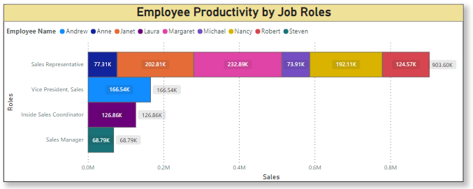

Yes, we can create stacked bar chart to find employee productivity across different job roles. I have use “Title as Roles” from employee table in Y-Axis, “TotalSales as Sales” from measure table in X-Axis and “FirstName as Employee Name” from employee table in Legend. **It will display “Sales Representative” role having highest sales around 903k and employee name “Margaret” have done maximum sales 232.8k**

Measure created to calculate Total Sales given below.



**Question 8: -** What is the distribution of employee tenure? Can we create a histogram or box plot to display it?

**Answer:**

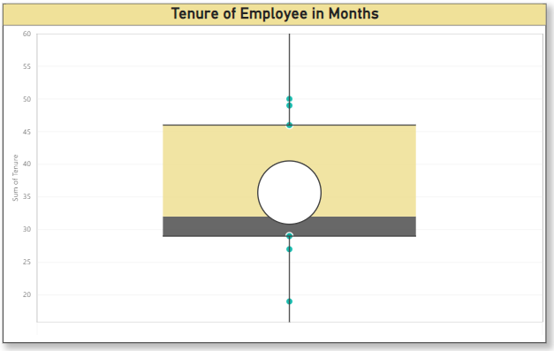Yes, we can create a box plot char to identify Employee tenure in months. I have created new column in employee table as Full Name using concat function between First name and Last name and new column as tenure to calculate number of months using Datediff function between hire date and order date. To calculate employee tenure, **it shows maximum tenure of employee is 50 months and minimum is 19.**

Measure created to calculate Tenure given below.



**Question 9: -** Can we visualize employee performance ratings or KPIs using a radar chart or bullet graph?

**Answer:**

Yes, we can calculate employee performance using radar chart. I have used “Full Name” from Employee table in Category and “Count of Order ID” from order table in Y-Axis which will provide us the number of orders by each employee.

Which will help us to recognize best performance Employee maximum the number of order maximum the employee ratings. **It shows Margaret Peacock is the best performing employee having 156 orders.**

**Question 10:** - What is the distribution of product ratings or reviews? Can we create a histogram or stacked bar chart to visualize it?

**Answer:**

Yes, we can create a histogram to calculate distribution of product rating.

I have created a new conditional column as UnitInStockRange to which shows range of UnitInStock. Highest the unit in stock shows the highest demand of product which means if unit in stock is more demand of that product is more which will help us to identify the best rating product. In this I have used “UnitInStockRange” in X-Axis and “Count of Product” in Y-Axis. **There is total 29 product in lies between 0-20 range which shows 29 product can have most demand.**

**Question 11: -** How does the sales volume vary across different product categories? Can we create a bar chart or treemap to display it?

**Answer:**

Yes, we can identify Total Sales across different product categories with the help of “Category Name” from Categories table in Category and “TotalSales as Sales” from measures in Values. **It shows category name “Beverages” having maximum sales around 267.87K.**

**Question 12: -** Can we visualize the pricing distribution of products using a box plot or violin plot?

**Answer:**

**

Yes, we can create box plot for pricing distribution of product it will shows us the product price. To display this, I have used ProductName from product table and created measure name as Total Unit price which will calculate the total unit price of each product and put it in Values and put ProductName in Axis. It will show us the range between which maximum pricing lies and outlier pricing.

Measure created to calculate Total Unit Price given below.



**Question 13: -** What is the distribution of supplier ratings or performance metrics? Can we create a bar chart or radar chart to visualize it?

**Answer:**

Yes, we can create a bar chart to visualize supplier performance, we can calculate supplier performance based on total quantity of product company have supplied to customers maximum se Total Quantity maximum se performance metrics. I have used “CompanyName” from supplier table in Y-Axis and “Sum of Quantity” from orders details in X-Axis. **It will display supplier company name Plutzer is having maximum quantity 4.1k.**

**Question 14:** - How does the cost or pricing structure vary across different suppliers? Can we create a box plot or stacked bar chart to display it?

**Answer:**

Yes, we can create stacked bar charts to identify pricing structure of each supplier. To calculate pricing structure, I have used “CompanyName” from supplier in Y-Axis and “AverageUnitPrice” from product in X-Axis which will shows us the average pricing of each supplier company. **It shows supplier company name Aux Joyeux is having maximum average price 141.**

**Question 15: -** Can we visualize the geographical distribution of suppliers using a map or bubble chart?

**Answer:**

Yes, we can create map chart to identify suppliers in different countries. I have used “Country” from supplier table in Location and “Count of supplierID” from supplier table in Bubble size. Which will display us the number of suppliers in each country.

**Dashboard**

**Home Page Dashboard**

This is the home page of my Northwind Traders Dashboard. It displays all the 5 categories: - Employees, Customers, Orders, Products, Suppliers after click on any of the category this will navigate us to that category dashboard.

**Employee Dashboard**

This is the Employee Dashboard which will help use to analyse Employee performance. It displays total employees and total sales by employees.

**Customer Dashboard**

It displays all the customers performance and help use to understand customers trend over time.

**Order Dashboard**

It displays all the important factors of order and order details. It helps us to track order processing days and total sales by each order ids.

**Product Dashboard**

It displays all the product details which will help us traders to maintain their stocks based on demand.

**Supplier Dashboard**

This dashboard will show suppliers in different countries, pricing structures and quantity shipped by each supplier.

**Solving EDA** **Questions**

**Question 1:** What are the key factors influencing customer retention or loyalty based on the dataset?

**Answer:**

Key factors to check customers loyalty is based on RFM. R stands for Recency, F stands for Frequency, M stands for Monetary. It helps you to understand loyalty of customers. Higher the frequency and lower the Recency gives you the loyal customers.

**Question 2: -** How do customer preferences vary based on their location or demographics? Can we explore this through interactive visualizations?

**Answer:**

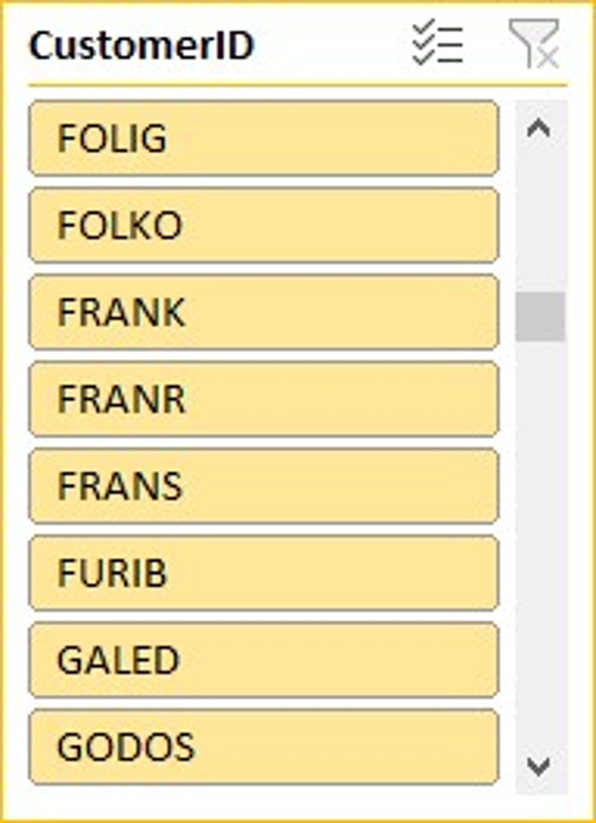We can find customer preferences vary across different location using this query which will provide us the Total Quantity, Total Unit in Order, and Total Revenue by customers in each country, which will help us to identify customers sales trend across different countries. A screenshot of a data

**Question 3: -** Are there any interesting patterns or clusters in customer behavior that can be visualized to identify potential market segments?

**Answer:**

This provides us the market pattern of customer across different country and different categories, it tell us the total quantity purchased by customer in each categories which will provide us the best market segment to focus on.

**Question 4: -** Are there any specific product categories or SKUs that contribute significantly to order revenue? Can we identify them through visualizations?

**Answer:**

This query will give order revenue generated by each category. It helps use to identify highest order revenue by categories. It shows Beverages have highest revenue of $267868.

**Question 5: -** Are there any correlations between order size and customer demographics or product categories? Can we explore this visually using scatter plots or heatmaps?

**Answer:**

This query helps us to create correlation between customers and order size. It also creates correlation between category and order size. Which display categoryID and amount of order done by it. And display most ordered Category name.

**Question 6**: - How does order frequency vary across different customer segments? Can we visualize this using bar charts or treemaps?

**Answer:**

This SQL command will provide us the order frequency across different customer segments. we have use 2 customer segments.

1. Customers Country

2. Customer Contact Role

It will show us the order frequency of customers across different country and different contact roles.

**Question 7: -** Are there any correlations between employee satisfaction levels and key performance indicators? Can we explore this visually through scatter plots or line charts?

**Answer:**

This command will provide us the Employee full name, total customers and total sales based on total sales we have given levels to each employee higher the sales higher the level based on that we have created scatter chart to identify correlation patterns. It shows employee Margaret Peacock have highest. Total Sales $232890 with satisfaction level 9.

**Question 8:** - How does employee turnover vary across different departments or job roles? Can we visualize this using bar charts or heatmaps?

**Answer:**

This SQL query will provide the last 3 years employee hire date. It will help us to analyse employee turnover across different roles. It shows Sales Representative have highest employee new hires and total employee number of employees.

**Question 9: -** Can we identify any patterns or clusters in employee skill sets or qualifications through visualizations? How can this information be used for talent management?

**Answer:**

This shows skill set of employees with the help of total tasks and total sales. EmployeeID 4 – Margaret Peacock, Sales Representative have the highest number of tasks with total sales $2096017.

**Question 10:** - Are there any correlations between product attributes (e.g., size, color, features) and sales performance? Can we explore this visually using scatter plots or heatmaps?

**Answer:**

In this question we have to find any correlation between products and sales performance. It shows weak relation between product unit in stock and total quantity sold this is because the less promote or product is not useful.

**Question 11:** - How does product demand fluctuate over different seasons or months? Can we visualize this through line charts or area charts?

**Answer:**

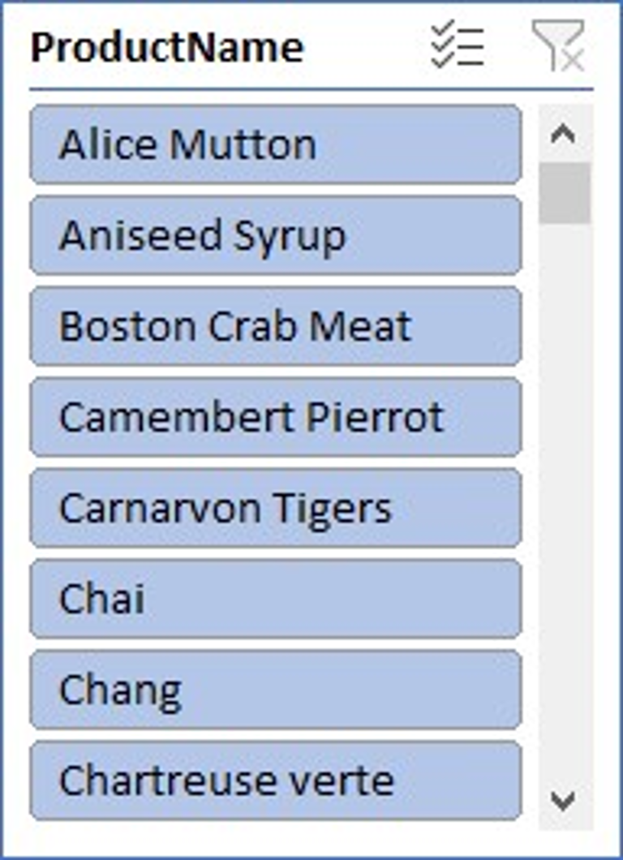

This query will provide the product demands in each month. It shows 5th month is having highest product demand with 276 product count.

**Question 12:** - Can we identify any outliers or anomalies in product performance or sales using visualizations? How can this information be used for product optimization?

**Answer:**

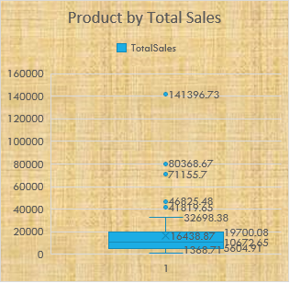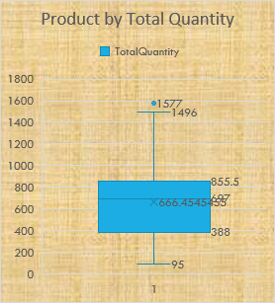

This query will provide the outliers in Total sales and Total quantity in product. Which will help us to analyse the product performance ranges based on total sales and total quantity**.**

**Question 13: -** Are there any correlations between supplier attributes (e.g., location, size, industry) and performance metrics (e.g., on-time delivery, product quality)? Can we explore this visually through scatter plots or heatmaps?

**Answer:**

This SQL command will show weak correlation between supplier attributes and its performance metrics. We have made scatter chart to identify supplier contact title and delivery time.

**Question 14: -** How does supplier performance vary across different product categories or departments? Can we visualize this using stacked bar charts or grouped column charts?

**Answer:**

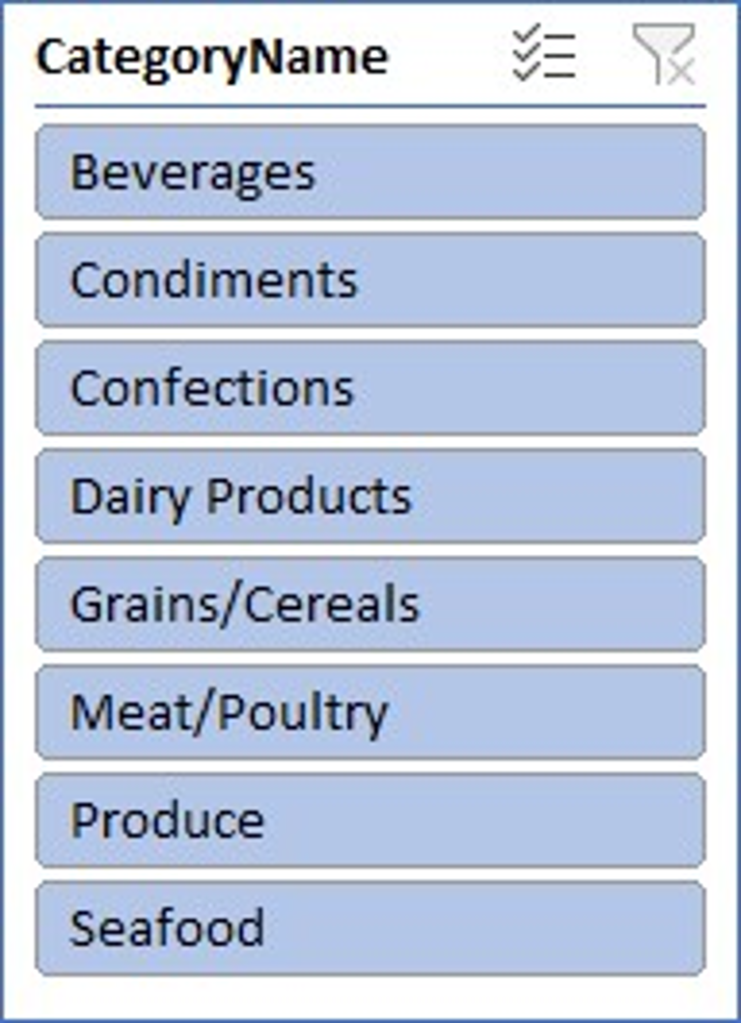

This SQL command will help us to identify supplier performance across different categories.

we have made combo chart to display supplier Ids and their average time and total quantity supplied by them in different product categories.

**Question 15: -** Can we identify any trends or patterns in supplier costs or pricing structures through visualizations? How can this information be used for procurement optimization?

**Answer:**

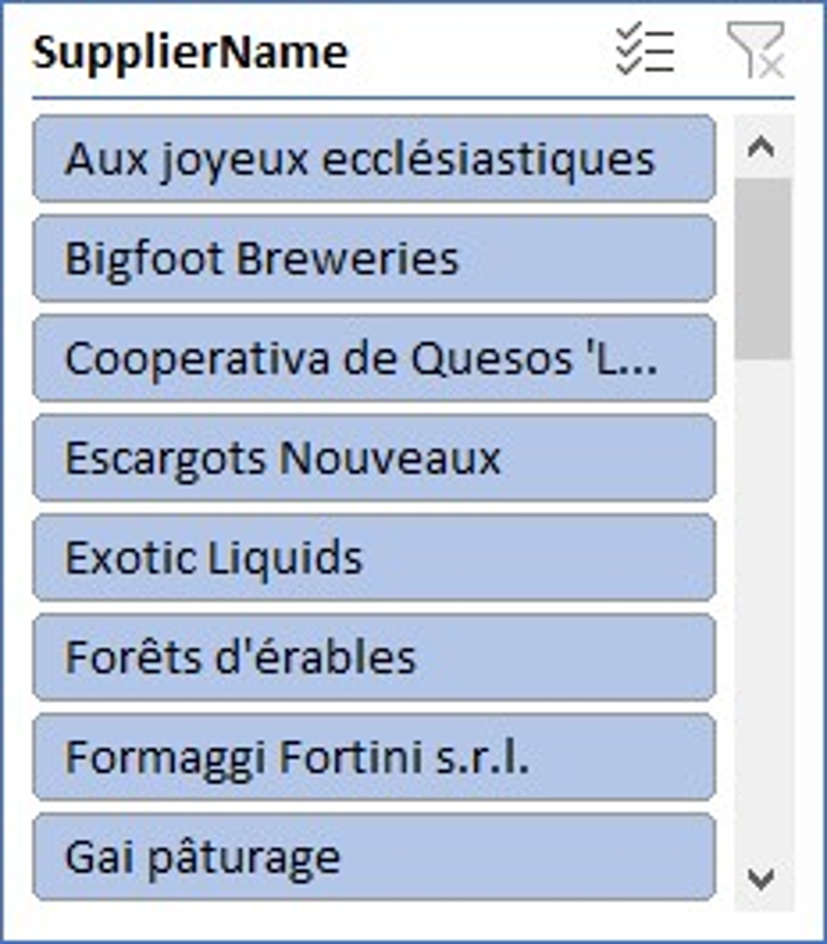

This command will provide us the average pricing of each supplier in different categories. Which help us to compare pricing between different suppliers in different categories.

**Conclusion**

**Customer Segmentation:** By analyzing customer purchasing behavior and demographics (such as region, industry, etc.), Northwind Traders can segment their customers effectively. This segmentation could help in targeting specific customer groups with tailored marketing strategies or product offerings.

**Sales Performance**: Examining sales data, including total sales, trends over time, and sales by product category or region, can provide insights into which products are performing well and which may need improvement. Identifying top-selling products and regions can inform inventory management and sales strategies.

**Employee Performance:** Analyzing employee sales performance, such as total sales generated, number of orders processed, or average order value, can help identify top-performing employees and areas where additional training or support may be needed.

**Inventory Trends:** Monitoring inventory levels, including units in stock, units on order, and reorder levels, can help optimize inventory management processes. Identifying products that frequently run out of stock or have excess inventory can inform purchasing and stocking decisions.

**Supplier Relationships:** Evaluating supplier performance, such as on-time delivery rates or quality of products, can help Northwind Traders maintain strong supplier relationships and ensure a reliable supply chain.

**Shipping Efficiency:** Analyzing shipping data, including average shipping times and costs by shipper, can help optimize shipping processes and reduce delivery times and costs.

**Overall Business Performance:** By combining insights from all areas of analysis, Northwind Traders can gain a holistic view of their business performance. This can help identify areas of strength and opportunities for improvement, ultimately leading to better decision-making and strategic planning.

**In conclusion,** leveraging the data available in the Northwind database through Power BI can provide valuable insights into customer behaviour, sales patterns, employee performance, inventory management, supplier relationships, shipping efficiency, and overall business performance. These insights can empower Northwind Traders to make data-driven decisions that drive business growth and competitiveness in the wholesale market landscape.